TRACK RECORD
Victorian transport services quarterly performance bulletin
ISSUE 68 – SERVICES JULY TO SEPTEMBER 2016

Established in April 2012, Public Transport Victoria (PTV) manages Victoria’s train, tram and bus services. PTV also provides a single contact point for customers wanting information on public transport timetables, services, tickets and improvement projects.
Public transport performance improved in the third quarter of 2016, with punctuality and reliability results increasing across metropolitan and regional train services.
There was a small decline in punctuality for metropolitan buses as a reflection of revised measurement systems for tracking bus performance.
Overall satisfaction with metropolitan services increased compared with last quarter, from 67.3 per cent up to 68.5 per cent. This was also an increase compared with the September 2015 quarter (67.8 per cent).

Contents
TRACK RECORD 1
Contents 4
Punctuality and reliability 5
Punctuality 5
Reliability 8
Quarterly City and Westona Loop Bypasses 9
Unplanned express services 9
Customer compensation 10
Payments 11
Metropolitan train and tram 11
V/Line 12
Bus 12
Customer satisfaction 13
Customer satisfaction 13
About customer satisfaction ratings 13
Overall satisfaction 14
Metropolitan trains 16
Metropolitan trams 17
Metropolitan buses 18
V/Line modes 19
V/Line trains 20
V/Line coaches 21
Travel behaviour and ticketing 22
Travel behaviour 22
myki device availability 23
Fare evasion 24
Attitudes toward Authorised Officers 24
Customer service 25
Website 25
Call centre 28
Industry-wide feedback 30
About industry feedback 30
Stakeholder share 30
Industry feedback 32
PTV feedback 33

Punctuality and reliability

Punctuality
Metropolitan trains are considered on time if they arrive no more than four minutes and 59 seconds after their scheduled time in the timetable.
Metropolitan trams are considered on time if they arrive no more than 59 seconds before or four minutes and 59 seconds after the scheduled time in the timetable.
Metropolitan buses are considered on time if they arrive no more than 59 seconds before or five minutes and 59 seconds after their scheduled time in the timetable.
Long distance regional trains are considered on time if they arrive no more than 10 minutes and 59 seconds after their scheduled time in the timetable.
Short distance regional trains are considered on time if they arrive no more than five minutes and 59 seconds after their scheduled time in the timetable.
Punctuality measures do not include replacement services (i.e. replacement buses and coaches) which operated during the V/Line restoration period (January – June 2016).
Note: Effective from Track Record 67, punctuality measures for metropolitan bus services have changed.
As of 1 April 2016, punctuality is measured as the proportion of services departing timing points no more than 59 seconds early and no more than 4 minutes and 59 seconds later than timetabled/scheduled. Data is collected by Victoria’s bus tracking system (BTS).
BTS systems collect information from global positioning system (GPS) devices on buses, and at approximately 20,000 bus stops across metropolitan Melbourne.
Prior to the introduction of BTS systems, data was collected through manual reporting mechanisms. Services were considered on time when they arrived no later than 5 minutes and 59 seconds late. Manual reporting was based on limited samples of 5–10 per cent of services.
Table 1: Train, tram and bus punctuality – percentage of services on-time
Mode | Threshold | Jul–Sep 2015 | Oct–Dec 2015 | Jan–Mar 2016 | Apr–Jun 2016 | Jul–Sep 2016
Metropolitan trains | 4 minutes, 59 seconds late | 92.8 | 93.0 | 91.6 | 92.4 | 92.6
Metropolitan trams – average over route | 4 minutes, 59 seconds late | 85.0 | 82.3 | 83.7 | 83.9 | 84.3
V/Line trains | punctuality | 87.7 | 87.8 | 81.9 | 88.1 | 90.2
Metropolitan trams – at destination | 4 minutes, 59 seconds late | 76.3 | 72.3 | 74.6 | 74.2 | 74.7
Metropolitan buses – average over route | punctuality | 80.0 | 78.5 | 78.6 | 79.4 | 81.4
Metropolitan buses – old measure | punctuality | 89.8 | 90.8 | 89.6 | — | —

Figure 1: Train, tram and bus punctuality – percentage of services on-time
Table 2: Metropolitan train punctuality – percentage of peak services on-time at destination
Line | Jul – Sep 2015 | Oct – Dec 2015 | Jan – Mar 2016 | Apr – Jun 2016 | Jul – Sep 2016
Alamein | 93.4% | 91.5% | 91.2% | 90.4% | 92.7%
Belgrave | 87.2% | 89.0% | 87.9% | 80.3% | 81.9%
Craigieburn | 91.5% | 90.8% | 90.3% | 91.3% | 91.1%
Cranbourne | 89.4% | 88.5% | 84.8% | 83.9% | 85.8%
Frankston | 89.4% | 88.3% | 86.5% | 93.5% | 90.7%
Glen Waverley | 94.7% | 95.1% | 94.6% | 94.9% | 94.8%
Hurstbridge | 92.2% | 93.1% | 92.1% | 91.9% | 93.3%
Lilydale | 89.0% | 91.3% | 88.5% | 85.4% | 86.8%
Pakenham | 91.0% | 89.8% | 85.9% | 86.0% | 86.5%
Sandringham | 96.8% | 96.8% | 93.6% | 94.1% | 93.7%
South Morang | 95.2% | 95.8% | 96.0% | 94.8% | 95.2%
Stony Point | 96.9% | 96.1% | 92.7% | 94.4% | 87.8%
Sunbury | 92.3% | 92.4% | 88.8% | 91.3% | 91.6%
Upfield | 95.0% | 93.5% | 92.7% | 93.7% | 94.1%
Werribee | 93.0% | 93.2% | 89.4% | 91.0% | 93.0%
Williamstown | 94.9% | 94.6% | 92.0% | 94.3% | 94.7%
Network Total | 92.3% | 92.3% | 90.2% | 90.7% | 91.1%
Table 3: Metropolitan train punctuality – percentage of off-peak services on-time at destination
Line | Jul – Sep 2015 | Oct – Dec 2015 | Jan – Mar 2016 | Apr – Jun 2016 | Jul – Sep 2016
Alamein | 95.2% | 95.6% | 94.0% | 93.7% | 94.7%
Belgrave | 91.7% | 93.1% | 92.4% | 89.3% | 89.9%
Craigieburn | 92.3% | 92.2% | 92.7% | 93.3% | 93.5%
Cranbourne | 89.7% | 88.7% | 87.8% | 88.2% | 87.7%
Frankston | 89.0% | 89.1% | 89.7% | 94.6% | 92.2%
Glen Waverley | 96.1% | 96.4% | 97.2% | 97.7% | 97.9%
Hurstbridge | 95.0% | 95.7% | 93.4% | 94.6% | 94.5%
Lilydale | 93.2% | 94.0% | 91.7% | 90.9% | 92.4%
Pakenham | 88.8% | 88.6% | 86.5% | 86.5% | 87.5%
Sandringham | 95.2% | 95.5% | 94.1% | 95.8% | 95.3%
South Morang | 94.5% | 96.2% | 94.5% | 94.2% | 95.9%
Stony Point | 97.4% | 95.1% | 94.4% | 96.4% | 92.9%
Sunbury | 93.5% | 93.7% | 88.7% | 93.7% | 93.7%
Upfield | 94.5% | 93.5% | 93.4% | 94.8% | 95.1%
Werribee | 93.6% | 94.1% | 92.7% | 94.1% | 93.8%
Williamstown | 96.0% | 95.3% | 94.8% | 95.8% | 96.0%
Network Total | 93.1% | 93.4% | 92.2% | 93.3% | 93.4%

Reliability
Metropolitan train reliability is measured as the percentage of the timetable that is delivered. Non-delivery of services includes cancellations, trains that run short and trains that bypass the City or Altona Loops.
Metropolitan tram reliability is based on the percentage of the timetable delivered. Non-delivery of services includes cancellations and trams that run short.
Metropolitan bus reliability is the percentage of services that operate and are completed.
Regional train reliability is measured as the percentage of scheduled services that are delivered.
Reliability measures do not include replacement services (i.e. replacement buses and coaches) which operated during the V/Line restoration period (January – June 2016).
Table 4: Train and tram reliability – percentage of timetable delivered
Mode | Measure | Jul – Sep 2015 | Oct – Dec 2015 | Jan – Mar 2016 | Apr –Jun 2016 | Jul – Sep 2016
Metropolitan trains | % timetable delivered | 98.9 | 98.8 | 98.3 | 98.8 | 98.8
Metropolitan trams | % timetable delivered | 99.0 | 98.7 | 98.6 | 98.8 | 98.9
V/Line trains | % services delivered | 98.0 | 97.4 | 92.5 | 98.1 | 98.3
Metropolitan buses | % services delivered | >99.9 | >99.9 | >99.9 | >99.9 | >99.9

Figure 2: Train, tram and bus reliability – percentage of timetable delivered

Quarterly City and Westona Loop Bypasses
Table 5: Quarterly City and Westona Loop Bypasses
Line | Q3 2015 | Q4 2015 | Q1 2016 | Q2  2016 | Q3  2016 | Services scheduled to run through the loop Q3 2016
Alamein | 53 | 49 | 54 | 61 | 57 | 1,365
Belgrave | 129 | 96 | 140 | 108 | 105 | 3,987
Craigieburn | 24 | 36 | 26 | 18 | 16 | 6,523
Cranbourne | 176 | 165 | 246 | 204 | 168 | 3,581
Frankston | 146 | 153 | 157 | 107 | 125 | 3,641
Glen Waverley | 27 | 51 | 55 | 41 | 43 | 3,897
Hurstbridge | 15 | 17 | 35 | 11 | 39 | 6,366
Lilydale | 162 | 151 | 195 | 166 | 173 | 7,224
Pakenham | 234 | 215 | 247 | 204 | 165 | 6,708
Sandringham | 27 | 34 | 33 | 24 | 21 | 1,368
South Morang | 25 | 14 | 34 | 13 | 37 | 5,919
Sunbury | 18 | 40 | 20 | 14 | 11 | 6,537
Upfield | 15 | 22 | 20 | 12 | 11 | 4,785
Werribee (Delivered Bypassing City Loop) | 1 | 14 | 6 | 7 | 10 | 7
Werribee (Delivered Bypassing Westona Loop) | 74 | 110 | 79 | 72 | 86 | 8,642
Werribee (Delivered Bypassing Both Loops) | – | – | 1 | – | 3 | 1,240
Grand Total | 1,126 | 1,167 | 1,348 | 1,062 | 1,070 | 71,790

There were 984 bypasses of the City Loop this quarter, which is 1.4 per cent of the 71,790 services scheduled to run through the loop during this time.
There were 86 bypasses of the Westona Loop, which is 1.0 per cent of the 8,642 services scheduled to run through the loop during this time.

Unplanned express services
Table 6: Quarterly unplanned express services
Measure | Jul – Sep 2015 | Oct – Dec 2015 | Jan – Mar 2016 | Apr – Jun 2016 | Jul – Sep 2016
Total number of timetabled services | 192,101 | 188,832 | 190,166 | 192,284 | 194,826
Number of express run services | 82 | 75 | 107 | 46 | 18
Percentage of total services run as unplanned express | 0.0 | 0.0 | 0.1 | 0.0 | 0.0
The percentage of services run as unplanned express over the September 2016 quarter was 0.01 per cent.

Customer compensation
Train and tram operators are expected to deliver a punctual and reliable service for customers.
PTV insists that operators do everything they can to deliver services in line with the agreed timetable.
Where operators fall short, they are required to pay compensation to customers, in the form of complimentary travel. Only customers who travel with a periodical ticket of four weeks or more are eligible to receive compensation.
Table 7: Service level thresholds for compensation (per cent)
Measure | Threshold | Trains | Trams | V/Line
Punctuality | Arrival by 4 minutes, 59 seconds | 88 | 77 | -
 | Arrival by 5 minutes, 59 seconds | - | - | 92*
Reliability | Percentage of timetable delivered | 98 | 98 | -
 | Percentage of services delivered | - | - | 96
* For long distance V/Line services, on-time arrival is defined as arriving no later than 10 minutes and 59 seconds after the timetabled arrival time
Metropolitan trains
Customer compensation was not paid for metropolitan trains this quarter.
Metropolitan trams
Customer compensation was not paid for metropolitan trams this quarter.
V/Line
In July, passenger compensation was payable on all lines except Ararat & Maryborough, Seymour, Shepparton and Swan Hill & Echuca as punctuality was below the applicable threshold (92.0 per cent). Passenger compensation is also payable for reliability on the Albury corridor as performance was below the applicable threshold (96.0 per cent).
In August, passenger compensation was payable on all lines except Ararat & Maryborough, Shepparton and Swan Hill & Echuca as punctuality was below the applicable threshold
(92.0 per cent). Passenger compensation is also payable for reliability on the Albury corridor as performance was below the applicable threshold (96.0 per cent).
In September, passenger compensation was payable on all lines except Ararat & Maryborough, Geelong, Shepparton and Swan Hill & Echuca as punctuality was below the applicable threshold (92.0 per cent). Passenger compensation is not payable for reliability on any line as performance was above the applicable threshold (96.0 per cent).

Payments

Metropolitan train and tram
Metro Trains and Yarra Trams receive regular payments from Public Transport Victoria to cover the delivery of services and the operation and development of the networks. The terms of these payments are outlined in operator franchise agreements.
PTV requires that operators meet agreed performance targets. Penalties or incentives are paid depending on how operators perform against these targets.
Incentive payments are based on a detailed measure of the passenger impact of service disruptions. These include delays, cancellations, short services and a number of other disruption types (including trains that bypass the City and/or Westona loops).
Each disruption is multiplied by an agreed 'passenger weighting' for that service which depends on the route, the time of day, and the direction of the service. Longer delays result in higher penalties. Operators can receive bonus payments or incur penalties depending on whether the level of disruption is above or below agreed levels in the contracts.
Table 8: Metropolitan train payments ($'000s)
Payment type | Jul – Sep 2015 | Oct – Dec 2015 | Jan – Mar 2016 | Apr – Jun 2016 | Jul – Sep 2016
Base contract | 50,989 | 62,078 | 49,384 | 59,471 | 55,808
Incentive or penalty | 3,295 | 3,457 | 110 | 2,127 | 2,455
Customer Experience Performance Regime | 0 | 200 | 0 | 0 | 0
Revenue Reset Adjustment Payment | 19,492 | 17,864 | 28,954 | 28,954 | 20,636
Maintenance and projects¹ | 102,425 | 76,490 | 68,278 | 64,213 | 63,495
Rolling stock² | 27,852 | 24,315 | 23,220 | 19,688 | 29,445
Operations and systems³ | 18,775 | 11,408 | 13,049 | 12,233 | 17,322
TOTAL | 222,828 | 195,812 | 182,995 | 186,686 | 189,161
¹ Maintenance and projects combines maintenance and capital projects payments
² Rolling stock payments include rolling stock adjustments and exams
³ Operations and systems include payments for business system upgrades, driver establishment, electricity, and employee entitlements
Table 9: Metropolitan tram payments ($'000s)
Payment type | Jul – Sep 2015 | Oct – Dec 2015 | Jan – Mar 2016 | Apr – Jun 2016 | Jul – Sep 2016
Base contract | 3,494 | 5,903 | 2,986 | 480 | 4,168
Incentive and penalty | -42 | -1,560 | -576 | -1,314 | -1,067
Customer Experience Performance Regime | 0 | 439 | 0 | 0 | 0
Revenue Reset Adjustment Payment | 19,619 | 19,619 | 16,377 | 17,859 | 20,745
Maintenance and projects¹ | 16,349 | 17,522 | 15,065 | 24,549 | 11,375
Rolling stock | 8,767 | 8,767 | 8,767 | 8,767 | 8,767
Operations and systems² | 3,596 | 4,692 | 3,772 | 3,104 | 3,213
TOTAL | 51,783 | 55,383 | 46,391 | 53,445 | 47,201
¹ Maintenance and projects combines maintenance and capital projects payments
² Operations and systems payments include business system upgrades, electricity and employee entitlements

V/Line
Regional coach payments are made to V/Line, which is a state-owned enterprise, however regional train payments and penalties have ceased following the signing of the V/Line services agreement.
Table 10: Regional train and coach payments ($'000s)
Payment type | Jul – Sep 2015 | Oct – Dec 2015 | Jan – Mar 2016 | Apr – Jun 2016 | Jul – Sep 2016
Base contract | 78,570 | 87,057 | 82,866 | 129,836 | 132,052
Regional Coaches | 8,573 | 8,573 | 8,573 | 8,573 | 0
Farebox | 22,698 | 20,919 | 21,671 | 21,508 | 22,698
Rolling stock | 8,953 | 8,953 | 8,953 | 8,953 | 8,953
Total | 118,794 | 125,502 | 122,063 | 168,870 | 163,703

Bus
PTV has individual contracts with bus operators to run services in Melbourne and regional areas. Payments are made to these operators to help deliver route and school bus services.
Table 11: Metropolitan, regional and school bus payments ($'000s)
Payment type | Jul – Sep 2015 | Oct – Dec 2015 | Jan – Mar 2016 | Apr – Jun 2016 | Jul – Sep 2016
Metropolitan | 144,852 | 146,536 | 144,751 | 146,975 | 150,621
Regional | 27,534 | 27,332 | 28,951 | 29,114 | 28,880
School | 56,144 | 56,214 | 37,287 | 56,113 | 57,306
Total | 228,530 | 230,081 | 210,989 | 232,201 | 236,808

Customer satisfaction

Customer satisfaction
Overall satisfaction with metropolitan services increased compared with last quarter, from 67.3 per cent up to 68.5 per cent. This was also an increase compared with the September 2015 quarter (67.8 per cent).
Overall satisfaction with metropolitan trains increased compared with last quarter, from 70.9 per cent up to 71.7 per cent. This was a slight increase compared to the September 2015 quarter (71.4 per cent).
Overall satisfaction with metropolitan trams decreased slightly compared with last quarter, from 75.2 per cent to 74.9 per cent. This was a slight decrease compared to September 2015 quarter (75.6 per cent).
Overall satisfaction with metropolitan buses increased slightly compared with last quarter, 76.0 per cent to 76.6 per cent. This was nevertheless a slight decrease compared to the September 2015 quarter (76.9 per cent).

Overall customer satisfaction with regional trains increased slightly compared with last quarter, from 74.5 per cent to 75.8 per cent. This was also a slight decrease compared to the September 2015 quarter (76.2 per cent). Compared with last quarter, there was a significant decrease in customer satisfaction with stations and stops. Compared with the June 2016 quarter, there was a significant increase in the likelihood of survey respondents to recommend regional trains as a transport option to others.
Overall customer satisfaction with regional coaches increased compared with last quarter, from 78.4 per cent to 80.8 per cent. The result was nevertheless a decrease compared to the September 2015 quarter (83.9 per cent).

About customer satisfaction ratings
All results except overall metropolitan satisfaction (six-point scale) are reported in a 0-10 scale. Results prior to April 2009 were reported on a six-point scale.

Overall satisfaction
Table 12: Metropolitan public transport modes overall satisfaction
Jul – Sep 2014 | Oct – Dec 2014 | Jan – Mar 2015 | Apr – Jun 2015 | Jul – Sep 2015 | Oct – Dec 2015 | Jan – Mar 2016 | Apr – Jun 2016 | Jul – Sep 2016
66.1 | 66.4 | 66.7 | 68.1 | 67.3 | 67.8 | 69.6 | 69.0 | 68.5
Note: These results are still presented in the six-point scale.
Figure 3: Metropolitan public transport modes overall satisfaction

Table 13a: Metropolitan trains individual overall satisfaction
Mode | Jul – Sep 2014 | Oct – Dec 2014 | Jan – Mar 2015 | Apr – Jun 2015 | Jul – Sep 2015 | Oct – Dec 2015 | Jan – Mar 2016 | Apr – Jun 2016 | Jul – Sep 2016
Metropolitan Trains | 71.4 | 71.5 | 71.9 | 71.2 | 71.4 | 73.5 | 73.5 | 70.9 | 71.7

Figure 4a: Metropolitan trains individual overall satisfaction

Table 13b: Metropolitan trams individual overall satisfaction
Mode | Jul – Sep 2014 | Oct – Dec 2014 | Jan – Mar 2015 | Apr – Jun 2015 | Jul – Sep 2015 | Oct – Dec 2015 | Jan – Mar 2016 | Apr – Jun  2016 | Jul – Sep 2016
Metropolitan Trams | 73.7 | 74.7 | 75.9 | 75.2 | 75.6 | 77.1 | 76.3 | 75.2 | 74.9

Figure 4b: Metropolitan trams individual overall satisfaction

Table 13c: Metropolitan buses individual overall satisfaction
Mode | Jul – Sep 2014 | Oct – Dec 2014 | Jan – Mar 2015 | Apr – Jun 2015 | Jul – Sep 2015 | Oct – Dec 2015 | Jan – Mar 2016 | Apr – Jun 2016 | Jul – Sep 2016
Metropolitan Buses | 76.2 | 75.2 | 76.5 | 76.6 | 76.9 | 76.1 | 77.7 | 76.0 | 76.6

Figure 4c: Metropolitan buses individual overall satisfaction

Metropolitan trains
Figure 5a: Satisfaction with key service aspects for metropolitan trains
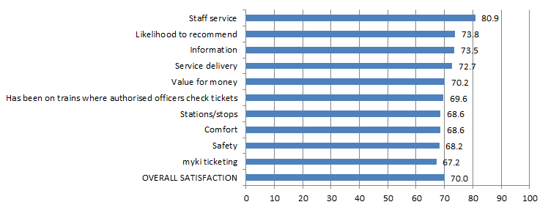
Table 14a: Satisfaction with key service aspects for metropolitan trains
Satisfaction indicator | Score | Significant change from previous quarter
Staff service | 80.9
Likelihood to recommend | 73.8
Information | 73.5
Service delivery | 72.7
Value for money | 70.2
Has been on trains where authorised officers check tickets | 69.6
Stations/stops | 68.6
Comfort | 68.6
Safety | 68.2
myki ticketing | 67.2
OVERALL SATISFACTION | 70.0

Metropolitan trams
Figure 5b: Satisfaction with key service aspects for metropolitan trams
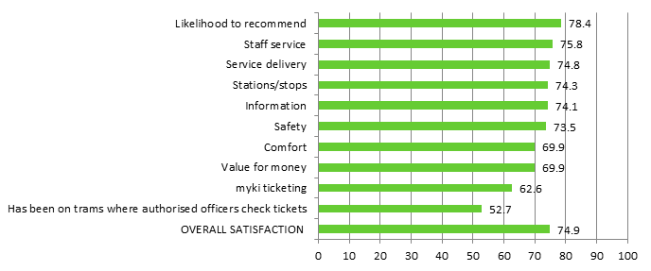

Table 14b: Satisfaction with key service aspects for metropolitan trams
Satisfaction indicator | Score | Significant change from previous quarter
Likelihood to recommend | 78.4
Staff service | 75.8
Stations/stops | 74.8
Service delivery | 74.8
Information | 74.1
Safety | 73.5
Comfort | 69.9
Value for money | 69.9
myki ticketing | 62.6
Has been on trams where authorised officers check tickets | 52.7
OVERALL SATISFACTION | 74.9

Metropolitan buses
Figure 5c: Satisfaction with key service aspects for metropolitan buses
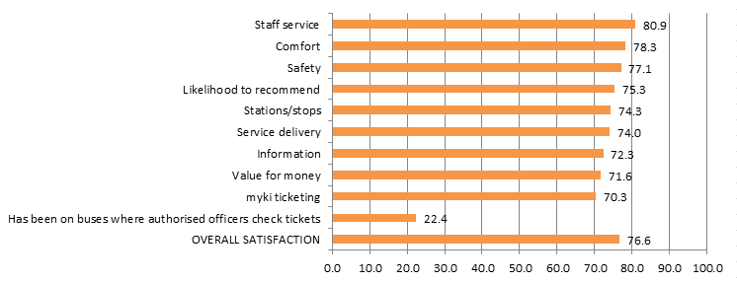

Table 14c: Satisfaction with key service aspects for metropolitan buses
Satisfaction indicator | Score | Significant change from previous quarter
Staff service | 80.9
Comfort | 78.3
Safety | 77.1
Likelihood to recommend | 75.3
Stations/stops | 74.3
Service delivery | 74.0
Information | 72.3
Value for money | 71.6
myki ticketing | 70.3
Has been on buses where authorised officers check tickets | 22.4
OVERALL SATISFACTION | 76.6

V/Line modes
Table 15a: V/Line trains individual overall satisfaction
Mode | Jul – Sep 2014 | Oct – Dec 2014 | Jan – Mar 2015 | Apr – Jun 2015 | Jul – Sep 2015 | Oct – Dec 2015 | Jan – Mar 2016 | Apr – Jun 2016 | Jul – Sep 2016
V/Line trains | 77.3 | 75.4 | 75.7 | 76.9 | 76.2 | 78.8 | 73.8 | 74.5 | 75.8

Table 15b: V/Line coaches individual overall satisfaction
Mode | Jul – Sep 2014 | Oct – Dec 2014 | Jan – Mar 2015 | Apr – Jun 2015 | Jul – Sep 2015 | Oct – Dec 2015 | Jan – Mar 2016 | Apr – Jun 2016 | Jul – Sep 2016
V/Line coaches | 80.3 | 80.8 | 84.6 | 85.7 | 83.9 | 86.1 | 81.6 | 78.4 | 80.8

Figure 6: V/Line individual overall satisfaction – trains and coaches

V/Line trains
Figure 7a: Satisfaction with key service aspects for V/Line trains
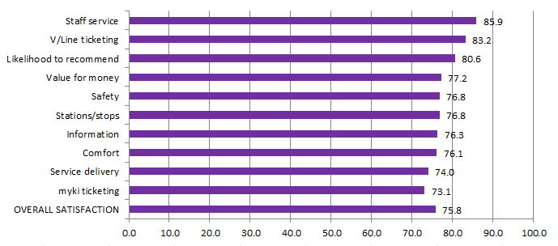
Table 16a: Satisfaction with key service aspects for V/Line trains
Satisfaction indicator | Score | Significant change from previous quarter
Staff service | 85.9
V/Line ticketing | 83.2
Likelihood to recommend | 80.6 | increase
Value for money | 77.2
Safety | 76.8
Stations/stops | 76.8
Information | 76.3
Comfort | 76.1
Service delivery | 74.0
myki ticketing | 73.1
OVERALL SATISFACTION | 75.8

V/Line coaches
Figure 7b: Satisfaction with key service aspects for V/Line coaches
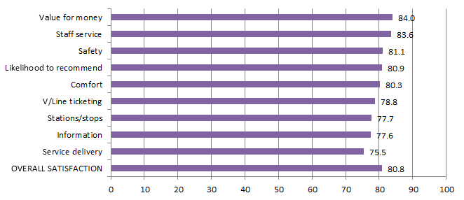

Table 16b: Satisfaction with key service aspects for V/Line coaches
Satisfaction indicator | Score | Significant change from previous quarter
Value for Money | 84.0
Staff service | 83.6
Safety | 81.1
Likelihood to recommend | 80.9
Comfort | 80.3
V/Line ticketing | 78.8
Stations/stops | 77.7 | increase
Information | 77.6
Service delivery | 75.5
OVERALL SATISFACTION | 80.8

Travel behaviour and ticketing

Travel behaviour
The proportion of non-users of public transport continues to remain stable in the September 2016 quarter with 9 per cent stating they hardly ever or never use public transport.
Figure 8: Main purpose of trip on weekday and weekend

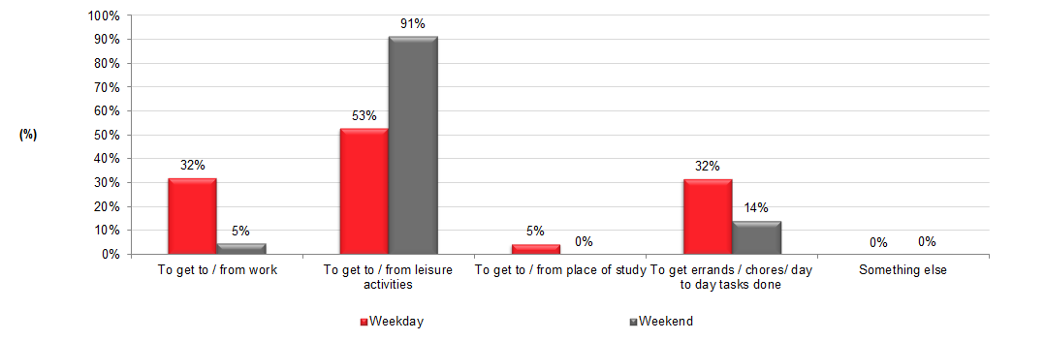
Table 17: Main purpose of trip on weekday and weekend
 | Weekday  (Jul – Sep 2016) | Weekend (Jul – Sep 2016)
To get to / from work | 32% | 5%
To get to / from leisure activities | 53% | 91%
To get to / from place of study | 5% | 0%
To get errands / chores/ day to day tasks done | 32% | 14%
Something else | 0% | 0%
The most popular reason for using public transport on weekdays is for leisure purposes
(53 per cent), which continues to lead commuting to work (32 per cent).
Weekend travel continues to be dominated by leisure purposes (91 per cent).

myki device availability
A private company, NTT Data Victorian Public Ticketing System Pty Ltd, is under contract to the Victorian Government to operate and maintain the myki ticketing system for Victoria’s public transport network.

Measurements included in the contract include targets to represent minimum levels of acceptable availability and performance, and specified levels of non-availability due to maintenance, servicing and breakdowns.

Table 18: Month-by-month NTT Data Key Performance Indicator calculated availability (per cent)

Equipment | July 2016 | August 2016 | September 2016
myki gate | 99.9733% | 99.9722% | 99.9637%
myki reader (mobile) | 99.9999% | 99.9973% | 99.9945%
myki reader (stationary) | 99.9978% | 99.9993% | 99.9980%

Figure 9: Month-by-month NTT Data Performance Indicator calculated availability (per cent)

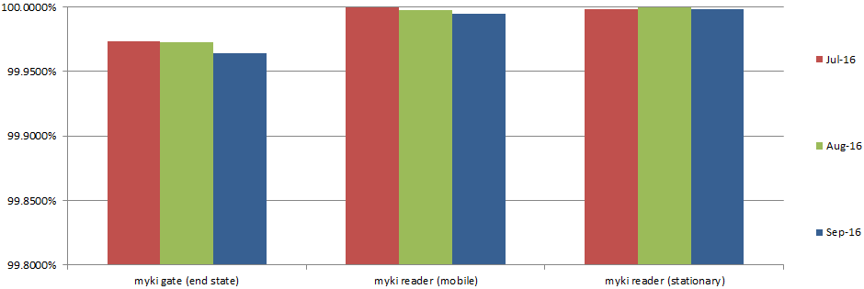

Monitoring of ticketing equipment

The status of ticketing equipment at railway stations is monitored via fixed communication. NTT Data therefore has accurate and up-to-date information on the availability of ticketing machines at railway stations and can promptly schedule repairs or servicing.

Mobile equipment on board trams and buses utilises wireless communications. Tram and bus operators are required to make vehicles with faulty equipment available to NTT Data for repairs and services. Measures and performance targets vary between modes.

Fare evasion
Attitudes toward Authorised Officers
Figure 10: Attitudes toward Authorised Officers (per cent)

Table 19: Detailed attitudes toward Authorised Officers
Attitudes towards authorised officers | Jul – Sep 2015 | Oct – Dec 2015 | Jan – Mar 2016 | Apr – Jun 2016 | Jul – Sep 2016
Neutral | 49% | 30% | 44% | 43% | 29%
Pleased | 16% | 27% | 18% | 18% | 23%
More secure | 19% | 22% | 18% | 23% | 30%
Annoyed | 4% | 6% | 5% | 5% | 6%
Nervous | 3% | 5% | 4% | 3% | 2%
Harassed | 3% | 3% | 4% | 2% | 3%
Have not seen them | 4% | 8% | 8% | 6% | 7%
Sample size | 503 | 400 | 400 | 400 | 400
Over half (53 per cent) of public transport users reported feeling positive towards Authorised Officers in the September 2016 quarter, up from last quarter (43 per cent).

The increase in overall positive feelings is driven by an increase in those feeling ‘more secure’ (from 23 per cent last quarter to 30 per cent this quarter).

Customer service

Website
PTV’s website provides journey planning, timetable, ticketing and marketing information for metropolitan Melbourne and regional Victoria. The PTV mobile phone apps for iPhones and Android handsets feature timetable and journey planning information.
Table 20: Website performance
 | Jul 2016 | Aug 2016 | Sep 2016 | Quarter total | Quarter on quarter change* | Year on year change*
Visits | 3.9m | 4.1m | 3.9m | 12.0m | +1% | +3%
Visitors | 1.8m | 1.9m | 1.8m | 4.7m* | +7% | +13%
Page views | 10.4m | 10.6m | 9.9m | 30.9m | -3% | -3%
*The quarter total for unique visitors may be higher than the aggregate of the three months as a visitor may visit the website more than once during a month, but is only counted once in the quarter total.
The PTV website received 11.9 million visits from customers in the September quarter. This is up slightly on the June quarter’s record total, and by 3% on the same period last year.

Journey planner

Customers planned a record 36.9 million journeys using PTV’s journey planner across our website, mobile phone apps and call centre during the quarter. This is a 4% increase on the record total of the previous quarter, and up by 12% on the same period last year.

News and service alterations

As with the previous quarter, level crossing improvements works were the most popular news topics during the quarter. An article about station closures and alterations on the Frankston line was viewed more than 128,000 times, while an article about works on the Belgrave and Lilydale lines in July was viewed more than 95,000 times.

Mobile apps

Customers used PTV’s mobile apps in 14.9 million sessions, up 8% on the previous quarter. Apps were installed on more than 150,000 new devices during the quarter.

Figure 11: Website visits

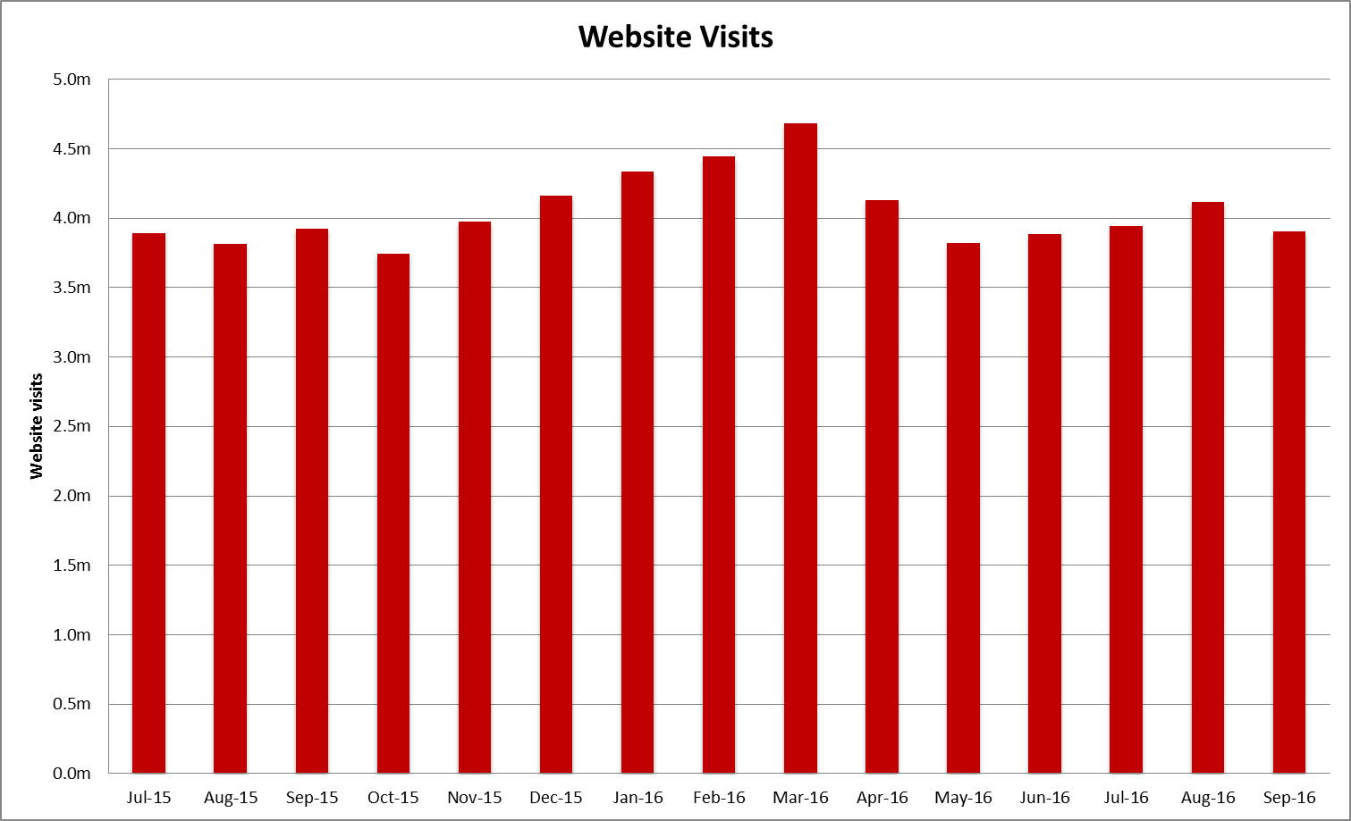

Source: Google analytics

Table 21: Website visits
Month | Jul 2015 | Aug 2015 | Sep 2015 | Oct 2015 | Nov 2015 | Dec 2015 | Jan 2016 | Feb 2016 | Mar 2016
Pageviews | 10,891,310 | 10,398,847 | 10,723,050 | 10,053,883 | 11,047,132 | 11,422,931 | 12,520,822 | 12,570,239 | 12,715,156
Visitors | 1,686,169 | 1,628,928 | 1,720,521 | 1,655,989 | 1,755,162 | 1,845,806 | 1,964,263 | 1,938,322 | 1,997,612
Visits | 3,895,115 | 3,819,592 | 3,928,755 | 3,746,178 | 3,978,079 | 4,162,017 | 4,334,701 | 4,446,234 | 4,686,265

Month | Apr 2016 | May 2016 | Jun 2016 | Jul 2016 | Aug 2016 | Sep 2016
Pageviews | 11,168,584 | 10,298,449 | 10,518,701 | 10,413,284 | 10,569,399 | 9,945,723
Visitors | 1,805,532 | 1,688,493 | 1,779,346 | 1,785,687 | 1,906,603 | 1,825,140
Visits | 4,131,197 | 3,824,990 | 3,887,248 | 3,946,087 | 4,117,388 | 3,908,743

Call Centre
PTV’s Call Centre provides journey and ticket information for metropolitan and regional services, as well as taking reservations and payment for V/Line tickets. It also collects feedback on behalf of all operators.
Table 22: Call Centre calls received
Measure | Jul 2016 | Aug 2016 | Sep 2016 | Quarter Total | Quarter on quarter change | Year on year change
Calls received | 99,067 | 97,550 | 95,861 | 292,478 | -2.7% | -1.2%
Call volumes decreased 2.7 per cent this quarter and decreased 1.2 per cent against the same period last year.
Figure 12: Call Volumes and Grade of Service (per cent)
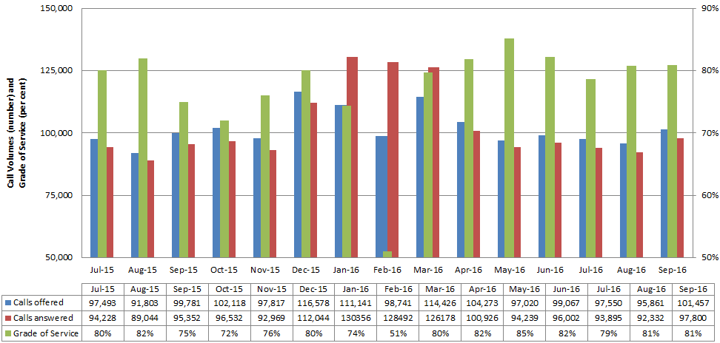
Table 23: Call Volumes and Grade of Service (per cent)
Calls | Jul 2015 | Aug 2015 | Sep 2015 | Oct 2015 | Nov 2015 | Dec 2015 | Jan 2016 | Feb 2016 | Mar 2016 | Apr 2016 | May 2016 | Jun 2016 | Jul 2016 | Aug 2016 | Sep 2016
offered | 97,493 | 91,803 | 99,781 | 102,118 | 97,817 | 116,578 | 111,141 | 98,741 | 114,426 | 104,273 | 97,020 | 99,067 | 97,550 | 95,861 | 101,457
answered | 94,228 | 89,044 | 95,352 | 96,532 | 92,969 | 112,044 | 130,356 | 128,492 | 126,178 | 100,926 | 94,239 | 96,002 | 93,895 | 92,332 | 97,800
GOS% | 80% | 82% | 75% | 72% | 76% | 80% | 74% | 51% | 80% | 82% | 85% | 82% | 79% | 81% | 81%
The Grade of Service target of 80 per cent of calls answered within 30 seconds was not met in July (79 per cent), but was met in August
(81 per cent) and September (81 per cent).

Industry-wide feedback

About industry feedback
Feedback data from all operators who have Resolve (Metro, Yarra, V/Line and PTV), is collected in a central database to aid industry-wide reporting and analysis. Bus data is provided to PTV by BusVic on behalf of its members.

Stakeholder share
During the September quarter, stakeholders reported receiving 20,449 cases (excluding special needs booking requests); this was a 4 per cent decrease on the previous quarter, and down by 19 per cent year-on-year.
PTV received 3,673 primary cases during the quarter; a 3 per cent decrease on the previous quarter, and a decrease of 24 per cent year-on-year.
Figure 13: Resolve – Stakeholder share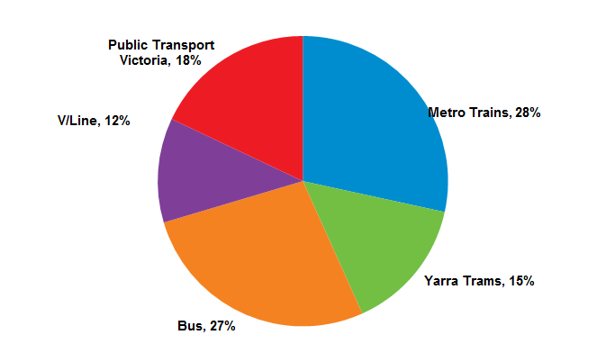
Table 24: Resolve – Stakeholder share
Operator | Total number of cases | Share of all cases | Quarter-on-quarter change | Year-on-year change
Metro | 5,810 | 28% | 2% | 0%
Yarra Trams | 3,039 | 15% | -7% | -54%
Bus | 5,547 | 27% | -2% | 22%
V/Line | 2,380 | 12% | -21% | -33%
PTV | 3,673 | 18% | -3% | -24%
Total | 20,449 | 100% | -4% | -19%
* Special needs booking requests have been removed
Types of feedback
Figure 14: Types of feedback

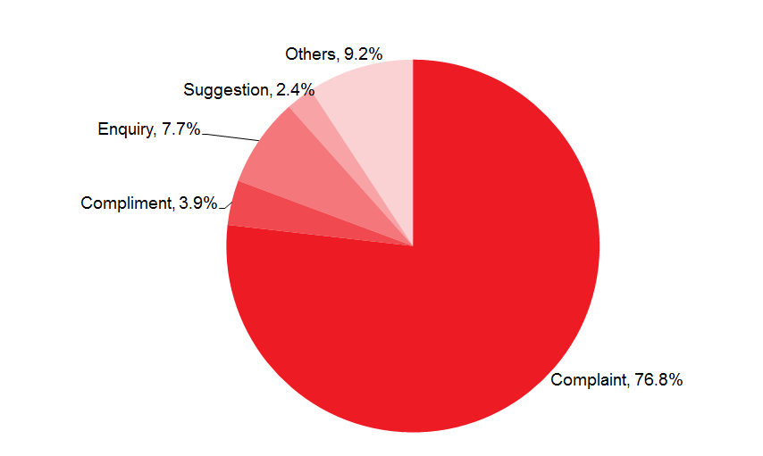
Table 25: Types of feedback
Feedback type | Percentage
Complaint | 76.8%
Compliment | 3.9%
Enquiry | 7.7%
Others | 9.2%
Suggestion | 2.4%

Industry feedback
Figure 15: Top five feedback issues across the industry

Note: Top issues for cases entered into the Resolve database (excluding performance-based compensation claims and compliments).
Table 26: Top five feedback issues across the industry
Issue | Percentage
Service delivery | 25.9%
Infrastructure | 20.2%
Staff | 16.7%
Provision of information | 15.9%
Ticketing and policy | 7.9%
Note: Top issues for cases entered into the Resolve database (excluding performance-based compensation claims and compliments).
Table 27: Breakdown of top industry issue*
Issue | Percentage
Delayed | 19.6%
Service Disruption | 16.1%
Cancellation | 14.1%
Service Change Needed | 8.6%
System improvements | 7.8%
*Top issue: Delayed:19.6 per cent of cases
Note: Bus industry feedback categorisation does not currently allow for analysis beyond the top PTV issues feedback.

PTV feedback
Excluding compliments, provision of information was the top feedback issue of the quarter, accounting for 28.6 per cent of PTV cases.

Mobile Products accounted for 36.4 per cent of the feedback received under provision of information. Some 43 per cent of the feedback came from the iPhone - PTV App 3.1.0.
Other issues consist of:
- Technical issues
- Future Enhancement
- Ease of use
Ticketing and policy accounted for 21 per cent of all PTV Cases. Requests include:
- Service Change Needed
- System Improvement
- Compensation Request
Some 3.9 per cent of cases received during the quarter were compliments. The top compliments were on staff and provision of information (accounting for 55 per cent of compliments)
- 77 per cent of the compliments from Staff related to Call Centre
- 66 per cent of the compliments from Provision of information related to Mobile Products

Figure 16: PTV top five feedback issues
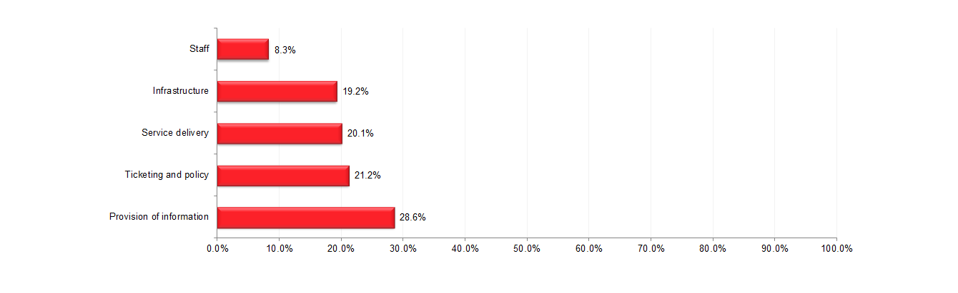
Note: Bus industry feedback categorisation does not currently allow for analysis beyond the top PTV issues feedback.
Table 28: PTV top five feedback issues
Issue | Percentage
Provision of Information | 28.6%
Ticketing and policy | 21.2%
Service delivery | 20.1%
Infrastructure | 19.2%
Staff | 8.3%
Note: Top issues for cases entered into the Resolve database (excluding performance-based compensation claims and compliments).
Table 29: Breakdown of top PTV issue*
Issue | Percentage
Mobile Products | 36.4%
Timetable | 19.4%
Website | 14.4%
Information Request | 9.7%
Journey Planner | 7.8%
*Top PTV issue: Provision of Information: 28.6 per cent of cases
Note: Bus industry feedback categorisation does not currently allow for analysis beyond the top PTV issues feedback.

