TRACK RECORD
Victorian transport services quarterly performance bulletin
ISSUE 70 – SERVICES JANUARY TO MARCH 2017

Established in April 2012, Public Transport Victoria (PTV) manages Victoria’s train, tram and bus services. PTV also provides a single contact point for customers wanting information on public transport timetables, services, tickets and improvement projects.
Public transport performance on metropolitan services series remained steady in the first quarter of 2017, with no significant changes in punctuality and reliability results. Regional service performance declined, with a drop in regional punctuality and reliability this quarter.
Overall satisfaction with metropolitan services increased compared with last quarter, from 67.5 per cent up to 68.8 per cent. There was no significant change compared with the March 2016 quarter (69.0 per cent).
Overall customer satisfaction with regional trains increased slightly compared with last quarter, from 75.0 per cent up to 77.1 per cent. This was a significant increase compared to the March 2016 quarter (73.8 per cent).
Contents
TRACK RECORD 1
Contents 4
Punctuality and reliability 5
Punctuality 5
Reliability 8
Quarterly City and Westona Loop Bypasses 9
Unplanned express services 9
Customer compensation 10
Payments 10
Metropolitan train and tram 11
V/Line 12
Bus 12
Customer satisfaction 13
Customer satisfaction 13
About customer satisfaction ratings 13
Overall satisfaction 14
Metropolitan trains 16
Metropolitan trams 17
Metropolitan buses 18
V/Line modes 19
V/Line trains 20
V/Line coaches 21
Travel behaviour and ticketing 22
Travel behaviour 22
myki device availability 23
Fare evasion 24
Attitudes toward Authorised Officers 24
Customer service 25
Website 25
Call centre 27
Industry-wide feedback 29
About industry feedback 29
Stakeholder share 29
Industry feedback 31
PTV feedback 32

Punctuality and reliability

Punctuality
Metropolitan trains are considered on time if they arrive no more than four minutes and 59 seconds after their scheduled time in the timetable.
Metropolitan trams are considered on time if they arrive no more than 59 seconds before or four minutes and 59 seconds after the scheduled time in the timetable.
Metropolitan buses are considered on time if they arrive no more than 59 seconds before or five minutes and 59 seconds after their scheduled time in the timetable.
Long distance regional trains are considered on time if they arrive no more than 10 minutes and 59 seconds after their scheduled time in the timetable.
Short distance regional trains are considered on time if they arrive no more than five minutes and 59 seconds after their scheduled time in the timetable.
Punctuality measures do not include replacement services (i.e. replacement buses and coaches) which operated during the V/Line restoration period (January – June 2016).
Note: Effective from Track Record 67, punctuality measures for metropolitan bus services have changed.
As of 1 April 2016, punctuality is measured as the proportion of services departing timing points no more than 59 seconds early and no more than 4 minutes and 59 seconds later than timetabled/scheduled. Data is collected by Victoria’s bus tracking system (BTS).
BTS systems collect information from global positioning system (GPS) devices on buses, and at approximately 20,000 bus stops across metropolitan Melbourne.
Prior to the introduction of BTS systems, data was collected through manual reporting mechanisms. Services were considered on time when they arrived no later than 5 minutes and 59 seconds late. Manual reporting was based on limited samples of 5–10 per cent of services.
Table 1: Train, tram and bus punctuality – percentage of services on-time
Mode | Threshold | Jan–Mar 2016 | Apr–Jun 2016 | Jul–Sep 2016 | Oct–Dec 2016 | Jan–Mar 2017
Metropolitan trains | 4 minutes, 59 seconds late | 91.6 | 92.4 | 92.6 | 91.4 | 91.9
Metropolitan trams – average over route | 4 minutes, 59 seconds late | 83.7 | 83.9 | 84.3 | 82.5 | 82.2
Metropolitan trams – at destination | 4 minutes, 59 seconds late | 74.6 | 74.2 | 74.7 | 72.1 | 72.2
V/Line trains | punctuality | 81.9 | 88.1 | 90.2 | 86.2 | 81.7
Metropolitan buses – average over route | punctuality | 78.6 | 79.4 | 81.4 | 79.6 | 80.1
Metropolitan buses – old measure | punctuality | 89.6 | — | — | — | —

Figure 1: Train, tram and bus punctuality – percentage of services on-time
Table 2: Metropolitan train punctuality – percentage of peak services on-time at destination
Line | Jan-Mar 2016 | Apr-Jun 2016 | Jul-Sep 2016 | Oct-Dec 2016 | Jan-Mar 2017
Alamein | 91.2% | 90.4% | 92.7% | 89.0% | 91.5%
Belgrave | 87.9% | 80.3% | 81.9% | 82.5% | 86.9%
Craigieburn | 90.3% | 91.3% | 91.1% | 88.7% | 88.5%
Cranbourne | 84.8% | 83.9% | 85.8% | 84.9% | 85.0%
Frankston | 86.5% | 93.5% | 90.7% | 89.1% | 88.6%
Glen Waverley | 94.6% | 94.9% | 94.8% | 95.2% | 95.7%
Hurstbridge | 92.1% | 91.9% | 93.3% | 92.1% | 92.6%
Lilydale | 88.5% | 85.4% | 86.8% | 84.8% | 89.7%
Pakenham | 85.9% | 86.0% | 86.5% | 87.0% | 87.4%
Sandringham | 93.6% | 94.1% | 93.7% | 95.8% | 95.7%
South Morang | 96.0% | 94.8% | 95.2% | 94.0% | 93.8%
Stony Point | 92.7% | 94.4% | 87.8% | 87.7% | 83.6%
Sunbury | 88.8% | 91.3% | 91.6% | 90.8% | 88.8%
Upfield | 92.7% | 93.7% | 94.1% | 91.8% | 90.2%
Werribee | 89.4% | 91.0% | 93.0% | 91.0% | 90.6%
Williamstown | 92.0% | 94.3% | 94.7% | 93.0% | 93.2%
Network total | 90.2% | 90.7% | 91.1% | 90.1% | 90.6%
Table 3: Metropolitan train punctuality – percentage of off-peak services on-time at destination
Line | Jan-Mar 2016 | Apr-Jun 2016 | Jul-Sep 2016 | Oct-Dec 2016 | Jan-Mar 2017
Alamein | 94.0% | 93.7% | 94.7% | 93.3% | 93.9%
Belgrave | 92.4% | 89.3% | 89.9% | 91.3% | 92.7%
Craigieburn | 92.7% | 93.3% | 93.5% | 91.9% | 90.6%
Cranbourne | 87.8% | 88.2% | 87.7% | 87.4% | 89.1%
Frankston | 89.7% | 94.6% | 92.2% | 88.9% | 88.5%
Glen Waverley | 97.2% | 97.7% | 97.9% | 96.7% | 97.7%
Hurstbridge | 93.4% | 94.6% | 94.5% | 93.4% | 94.7%
Lilydale | 91.7% | 90.9% | 92.4% | 90.6% | 93.5%
Pakenham | 86.5% | 86.5% | 87.5% | 86.0% | 86.1%
Sandringham | 94.1% | 95.8% | 95.3% | 96.5% | 95.7%
South Morang | 94.5% | 94.2% | 95.3% | 94.4% | 95.2%
Stony Point | 94.4% | 96.4% | 92.9% | 90.5% | 87.4%
Sunbury | 88.7% | 93.7% | 93.7% | 91.8% | 91.2%
Upfield | 93.4% | 94.8% | 95.1% | 93.1% | 93.3%
Werribee | 92.7% | 94.1% | 93.8% | 91.8% | 93.3%
Williamstown | 94.8% | 95.8% | 96.0% | 93.9% | 95.1%
Network total | 92.2% | 93.3% | 93.4% | 92.0% | 92.6%

Reliability
Metropolitan train reliability is measured as the percentage of the timetable that is delivered. Non-delivery of services includes cancellations, trains that run short and trains that bypass the City or Altona Loops.
Metropolitan tram reliability is based on the percentage of the timetable delivered. Non-delivery of services includes cancellations and trams that run short.
Metropolitan bus reliability is the percentage of services that operate and are completed.
Regional train reliability is measured as the percentage of scheduled services that are delivered.
Reliability measures do not include replacement services (i.e. replacement buses and coaches) which operated during the V/Line restoration period (January – June 2016).
Table 4: Train and tram reliability – percentage of timetable delivered
Mode | Measure | Jan-Mar 2016 | Apr-Jun 2016 | Jul-Sep 2016 | Oct-Dec 2016 | Jan-Mar 2017
Metropolitan trains | % timetable delivered | 98.3 | 98.8 | 98.8 | 98.6 | 98.9
Metropolitan trams | % timetable delivered | 98.6 | 98.8 | 98.9 | 98.7 | 98.4
V/Line trains | % services delivered | 92.5 | 98.1 | 98.3 | 97.9 | 96.8
Metropolitan buses | % services delivered | >99.9 | >99.9 | >99.9 | >99.9 | >99.9
Figure 2: Train, tram and bus reliability – percentage of timetable delivered

Quarterly City and Westona Loop Bypasses
Table 5: Quarterly City and Westona Loop Bypasses
Line | Q1 2016 | Q2  2016 | Q3  2016 | Q4 2016 | Q1 2017 | Services scheduled to run through the loop Q4 2016
Alamein | 54 | 61 | 57 | 55 | 55 | 1,302
Belgrave | 140 | 108 | 105 | 88 | 68 | 2,550
Craigieburn | 26 | 18 | 16 | 43 | 23 | 6,274
Cranbourne | 246 | 204 | 168 | 190 | 197 | 3,498
Frankston | 157 | 107 | 125 | 123 | 150 | 3,754
Glen Waverley | 55 | 41 | 43 | 63 | 39 | 3,786
Hurstbridge | 35 | 11 | 39 | 15 | 20 | 6,174
Lilydale | 195 | 166 | 173 | 156 | 134 | 7,781
Pakenham | 247 | 204 | 165 | 194 | 214 | 6,490
Sandringham | 33 | 24 | 21 | 16 | 16 | 1,404
South Morang | 34 | 13 | 37 | 10 | 26 | 5,747
Sunbury | 20 | 14 | 11 | 44 | 8 | 6,286
Upfield | 20 | 12 | 11 | 31 | 13 | 4,620
Werribee (Delivered Bypassing City Loop) | 6 | 7 | 10 | 5 | 6 | 7
Werribee (Delivered Bypassing Westona Loop) | 79 | 72 | 86 | 111 | 78 | 8,368
Werribee (Delivered Bypassing Both Loops) | 1 | – | 3 | – | – | 1,269
Grand Total | 1,348 | 1,062 | 1,070 | 1,144 | 1,047 | 69,310

There were 969 bypasses of the City Loop this quarter, which is 1.6 per cent of the 60,924 services scheduled to run through the loop during this time.
There were 78 bypasses of the Westona Loop, which is 0.9 per cent of the 8,368 services scheduled to run through the loop during this time.

Unplanned express services
Table 6: Quarterly unplanned express services
Measure | Jan-Mar 2016 | Apr-Jun 2016 | Jul-Sep 2016 | Oct-Dec 2016 | Jan-Mar 2017
Total number of timetabled services | 190,166 | 192,284 | 194,826 | 193,373 | 193,240
Number of express run services | 107 | 46 | 18 | 5 | 7
Percentage of total services run as unplanned express | 0.1 | 0.0 | 0.0 | 0.0 | 0.0
The percentage of services run as unplanned express over the March 2017 quarter was 0.004 per cent.

Customer compensation
Train and tram operators are expected to deliver a punctual and reliable service for customers.
PTV insists that operators do everything they can to deliver services in line with the agreed timetable.
Where operators fall short, they are required to pay compensation to customers, in the form of complimentary travel. Only customers who travel with a periodical ticket of four weeks or more are eligible to receive compensation.
Table 7: Service level thresholds for compensation (per cent)
Measure | Threshold | Trains | Trams | V/Line
Punctuality | Arrival by 4 minutes, 59 seconds | 88 | 77 | -
 | Arrival by 5 minutes, 59 seconds | - | - | 92*
Reliability | Percentage of timetable delivered | 98 | 98 | -
 | Percentage of services delivered | - | - | 96
* For long distance V/Line services, on-time arrival is defined as arriving no later than 10 minutes and 59 seconds after the timetabled arrival time
Metropolitan trains
Customer compensation was not paid for metropolitan trains this quarter.
Metropolitan trams
Customer compensation was not paid for metropolitan trams this quarter.
V/Line
In January, passenger compensation was payable on all lines as punctuality was below the applicable threshold (92.0 per cent). Compensation was also payable for reliability on the Albury, Bendigo and Geelong corridors as performance was below the applicable threshold (96.0 per cent).
In February, passenger compensation was payable on all lines as punctuality was below the applicable threshold (92.0 per cent).Compensation was also payable for reliability on the Albury and Bendigo lines as performance was below the applicable threshold (96.0 per cent).
In March, passenger compensation was payable on all lines as punctuality was below the applicable threshold (92.0 per cent). Compensation was also payable for reliability on the Albury and Bendigo lines as performance was below the applicable threshold (96.0 per cent).
Payments

Metropolitan train and tram
Metro Trains and Yarra Trams receive regular payments from Public Transport Victoria to cover the delivery of services and the operation and development of the networks. The terms of these payments are outlined in operator franchise agreements.
PTV requires that operators meet agreed performance targets. Penalties or incentives are paid depending on how operators perform against these targets.
Incentive payments are based on a detailed measure of the passenger impact of service disruptions. These include delays, cancellations, short services and a number of other disruption types (including trains that bypass the City and/or Westona loops).
Each disruption is multiplied by an agreed 'passenger weighting' for that service which depends on the route, the time of day, and the direction of the service. Longer delays result in higher penalties. Operators can receive bonus payments or incur penalties depending on whether the level of disruption is above or below agreed levels in the contracts.
Table 8: Metropolitan train payments ($'000s)
Payment type | Jan-Mar 2016 | Apr-Jun 2016 | Jul-  Sep 2016 | Oct-Dec 2016 | Jan-Mar 2017
Base contract | 49,384 | 59,471 | 55,808 | 61,614 | 52,676
Incentive or penalty | 110 | 2,127 | 2,544 | 3,514 | 2,496
Customer Experience Performance Regime | 0 | 0 | 0 | 0 | 0
Revenue Reset Adjustment Payment | 28,954 | 28,954 | 20,636 | 20,636 | 30,461
Maintenance and projects¹ | 68,278 | 64,213 | 63,495 | 61,119 | 63,167
Rolling stock² | 23,220 | 19,688 | 29,445 | 22,543 | 21,773
Operations and systems³ | 13,049 | 12,233 | 17,322 | 14,718 | 12,985
TOTAL | 182,994 | 186,685 | 189,250 | 184,144 | 183,558
¹ Maintenance and projects combines maintenance and capital projects payments
² Rolling stock payments include rolling stock adjustments and exams
³ Operations and systems include payments for business system upgrades, driver establishment, electricity, and employee entitlements
Table 9: Metropolitan tram payments ($'000s)
Payment type | Jan-Mar 2016 | Apr-Jun 2016 | Jul-Sep 2016 | Oct-Dec 2016 | Jan-Mar 2017
Base contract | 2,986 | 480 | 4,168 | 7,222 | -2,148
Incentive and penalty | -576 | -1,220 | -529 | -1,597 | -586
Customer Experience Performance Regime | 0 | 0 | 0 | 444 | 0
Revenue Reset Adjustment Payment | 16,377 | 17,859 | 20,745 | 20,745 | 19,237
Maintenance and projects¹ | 15,065 | 24,549 | 11,375 | 15,880 | 11,038
Rolling stock | 8,767 | 8,767 | 8,767 | 8,429 | 7,527
Operations and systems² | 3,772 | 3,104 | 3,213 | 8,511 | 3,178
TOTAL | 46,391 | 53,539 | 47,739 | 59,633 | 38,246
¹ Maintenance and projects combines maintenance and capital projects payments
² Operations and systems payments include business system upgrades, electricity and employee entitlements

V/Line
Regional coach payments are made to V/Line, which is a state-owned enterprise, however regional train payments and penalties have ceased following the signing of the V/Line services agreement.
Table 10: Regional train and coach payments ($'000s)
Payment type | Jan - Mar 2016 | Apr-Jun 2016 | Jul- Sep 2016 | Oct- Dec 2016 | Jan-Mar 2017
Base contract | 82,866 | 129,836 | 132,052 | 129,469 | 113,494
Regional Coaches | 8,573 | 8,573 | 0 | 0 | 0
Farebox | 21,671 | 21,508 | 22,698 | 23,299 | 25,623
Rolling stock | 8,953 | 8,953 | 8,953 | 8,953 | 8,953
Total | 122,063 | 168,870 | 163,703 | 161,721 | 148,071

Bus
PTV has individual contracts with bus operators to run services in Melbourne and regional areas. Payments are made to these operators to help deliver route and school bus services.
Table 11: Metropolitan, regional and school bus payments ($'000s)
Payment type | Jan-Mar 2016 | Apr-Jun 2016 | Jul-Sep 2016 | Oct-Dec 2016 | Jan- Mar 2017
Metropolitan | 144,751 | 146,975 | 150,621 | 151,528 | 155,331
Regional | 28,951 | 29,114 | 28,880 | 29,541 | 30,707
School | 37,287 | 56,113 | 57,306 | 57,318 | 39,159
Total | 210,989 | 232,201 | 236,808 | 238,387 | 225,198

Customer satisfaction

Customer satisfaction
Overall satisfaction with metropolitan services increased compared with last quarter, from 67.5 per cent up to 68.8 per cent. There was no significant change compared with the March 2016 quarter (69.0 per cent).
Overall satisfaction with metropolitan trains increased slightly compared with last quarter, from 72.6 per cent up to 73.5. There was no significant change compared with March 2016 quarter (73.5 per cent).
Compared with last quarter, there was a significant increase in satisfaction with safety (69.0 per cent up to 71.0 per cent).
Compared with the March 2016 quarter, there was a significant decrease in satisfaction with price (from 71.1 per cent down to 68.5 per cent).

Overall satisfaction with metropolitan trams decreased slightly compared with last quarter, from 76.4 per cent down to 76.2 per cent. This was also a slight decrease compared to March 2016 quarter (76.3 per cent).
Compared with the last quarter, there was a significant decrease in satisfaction with safety (from 76.1 per cent down to 74.5 per cent).

Overall satisfaction with metropolitan buses increased slightly compared with last quarter, from 76.1 per cent up to 76.7 per cent. This was nevertheless a slight decrease compared to the March 2016 quarter (77.7 per cent).

Compared with the March 2016 quarter, there was a significant decrease in satisfaction with service delivery (from 76.1 per cent down to 73.3 per cent).

Overall customer satisfaction with regional trains increased slightly compared with last quarter, from 75.0 per cent up to 77.1 per cent. This was a significant increase compared to the March 2016 quarter (73.8 per cent).
Compared with last quarter, there was a significant increase in customer satisfaction with V/Line ticketing (from 78.3 per cent up to 83.5 per cent).
Compared with the March 2016 quarter, there were significant increases in satisfaction with information (from 73.8 per cent up to 77.1 per cent), myki ticketing (from 70.9 per cent up to 75.4 per cent), and the likelihood of survey respondents to recommend regional trains (from 76.6 per cent up to 80.8 per cent).
Overall customer satisfaction with regional coaches increased slightly compared with last quarter, from 79.5 per cent up to 82.9 per cent. There was no significant change compared with the March 2016 quarter (81.6 per cent).

About customer satisfaction ratings
All results except overall metropolitan satisfaction (six-point scale) are reported in a 0-10 scale. Results prior to April 2009 were reported on a six-point scale.

Overall satisfaction
Table 12: Metropolitan public transport modes overall satisfaction
Jan – Mar 2015 | Apr – Jun 2015 | Jul – Sep 2015 | Oct – Dec 2015 | Jan – Mar 2016 | Apr – Jun 2016 | Jul – Sep 2016 | Oct – Dec 2016 | Jan – Mar 2017
66.7 | 68.1 | 67.3 | 67.8 | 69.6 | 69.0 | 68.5 | 67.5 | 68.8
Note: These results are still presented in the six-point scale.
Figure 3: Metropolitan public transport modes overall satisfaction

Table 13a: Metropolitan trains individual overall satisfaction
Mode | Jan – Mar 2015 | Apr – Jun 2015 | Jul – Sep 2015 | Oct – Dec 2015 | Jan – Mar 2016 | Apr – Jun 2016 | Jul – Sep 2016 | Oct – Dec 2016 | Jan – Mar 2017
Metropolitan Trains | 71.9 | 71.2 | 71.4 | 73.5 | 73.5 | 70.9 | 71.7 | 72.6 | 73.5

Figure 4a: Metropolitan trains individual overall satisfaction

Table 13b: Metropolitan trams individual overall satisfaction
Mode | Jan – Mar 2015 | Apr – Jun 2015 | Jul – Sep 2015 | Oct – Dec 2015 | Jan – Mar 2016 | Apr – Jun  2016 | Jul – Sep 2016 | Oct – Dec 2016 | Jan – Mar 2017
Metropolitan Trams | 75.9 | 75.2 | 75.6 | 77.1 | 76.3 | 75.2 | 76.4 | 76.4 | 76.2

Figure 4b: Metropolitan trams individual overall satisfaction

Table 13c: Metropolitan buses individual overall satisfaction
Mode | Jan – Mar 2015 | Apr – Jun 2015 | Jul – Sep 2015 | Oct – Dec 2015 | Jan – Mar 2016 | Apr – Jun 2016 | Jul – Sep 2016 | Oct – Dec 2016 | Jan – Mar 2017
Metropolitan Buses | 75.2 | 76.5 | 76.6 | 76.9 | 76.1 | 77.7 | 76.0 | 76.1 | 76.6

Figure 4c: Metropolitan buses individual overall satisfaction

Metropolitan trains
Figure 5a: Satisfaction with key service aspects for metropolitan trains
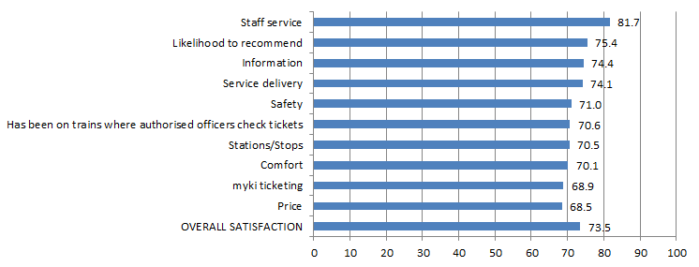
Table 14a: Satisfaction with key service aspects for metropolitan trains
Satisfaction indicator | Score | Significant change from previous quarter
Staff service | 81.7 | –
Likelihood to recommend | 75.4 | –
Information | 74.4 | –
Service delivery | 74.1 | –
Safety | 71.0 | increase
Has been on trains where authorised officers check tickets | 70.6 | –
Stations/Stops | 70.5 | –
Comfort | 70.1 | –
myki ticketing | 68.9 | –
Price | 68.5 | –
OVERALL SATISFACTION | 73.5 | –

Metropolitan trams
Figure 5b: Satisfaction with key service aspects for metropolitan trams
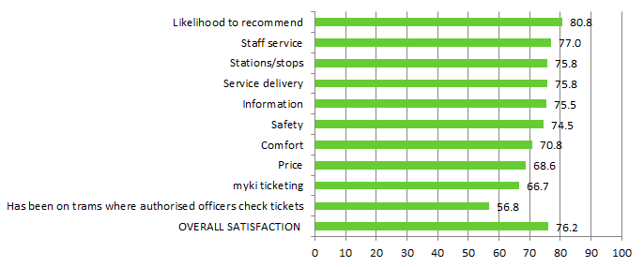

Table 14b: Satisfaction with key service aspects for metropolitan trams
Satisfaction indicator | Score | Significant change from previous quarter
Likelihood to recommend | 80.8 | –
Staff service | 77.0 | –
Service delivery | 75.8 | –
Stations/stops | 75.8 | –
Information | 75.5 | –
Safety | 74.5 | decrease
Comfort | 70.8 | –
Price | 68.6 | –
myki ticketing | 66.7 | –
Has been on trams where authorised officers check tickets | 56.8 | –
OVERALL SATISFACTION | 76.2 | –

Metropolitan buses
Figure 5c: Satisfaction with key service aspects for metropolitan buses
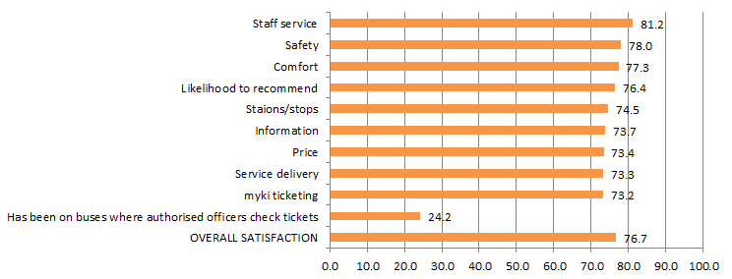

Table 14c: Satisfaction with key service aspects for metropolitan buses
Satisfaction indicator | Score | Significant change from previous quarter
Staff service | 81.2 | –
Safety | 78.0 | –
Comfort | 77.3 | –
Likelihood to recommend | 76.4 | –
Stations/stops | 74.5 | –
Information | 73.7 | –
Price | 73.4 | –
Service delivery | 73.3 | –
myki ticketing | 73.2 | –
Has been on buses where authorised officers check tickets | 24.2 | –
OVERALL SATISFACTION | 76.7 | –

V/Line modes
Table 15a: V/Line trains individual overall satisfaction
Mode | Jan – Mar 2015 | Apr – Jun 2015 | Jul – Sep 2015 | Oct – Dec 2015 | Jan – Mar 2016 | Apr – Jun 2016 | Jul – Sep 2016 | Oct – Dec 2016 | Jan – Mar 2017
V/Line trains | 75.7 | 76.9 | 76.2 | 78.8 | 73.8 | 74.5 | 75.8 | 75.0 | 77.1

Table 15b: V/Line coaches individual overall satisfaction
Mode | Jan – Mar 2015 | Apr – Jun 2015 | Jul – Sep 2015 | Oct – Dec 2015 | Jan – Mar 2016 | Apr – Jun 2016 | Jul – Sep 2016 | Oct – Dec 2016 | Jan – Mar 2017
V/Line coaches | 80.8 | 84.6 | 85.7 | 83.9 | 86.1 | 81.6 | 78.4 | 80.8 | 82.9

Figure 6: V/Line individual overall satisfaction – trains and coaches

V/Line trains
Figure 7a: Satisfaction with key service aspects for V/Line trains
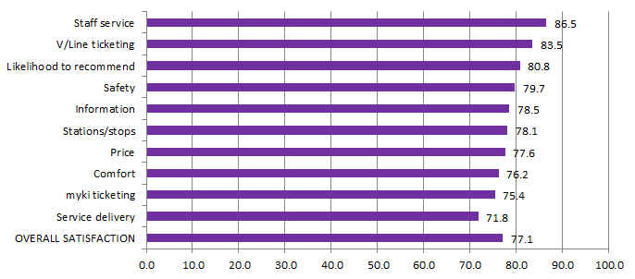
Table 16a: Satisfaction with key service aspects for V/Line trains
Satisfaction indicator | Score | Significant change from previous quarter
Staff service | 86.5
V/Line ticketing | 83.5 | increase
Likelihood to recommend | 80.8
Safety | 79.7
Information | 78.5
Stations/stops | 78.1
Price | 77.6
Comfort | 76.2
myki ticketing | 75.4
Service delivery | 71.8
OVERALL SATISFACTION | 75.0

V/Line coaches
Figure 7b: Satisfaction with key service aspects for V/Line coaches
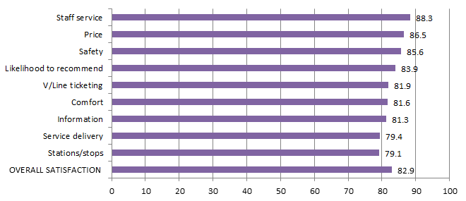

Table 16b: Satisfaction with key service aspects for V/Line coaches
Satisfaction indicator | Score | Significant change from previous quarter
Staff service | 88.3
Price | 86.5
Safety | 85.6
Likelihood to recommend | 83.9
V/Line ticketing | 81.9 | increase
Comfort | 81.6
Information | 81.3
Service delivery | 79.4
Stations/stops | 79.1
OVERALL SATISFACTION | 82.9

Travel behaviour and ticketing

Travel behaviour
The proportion of non-users of public transport continued to remain stable in the March 2017 quarter with 14 per cent stating they hardly ever or never use public transport.
Figure 8: Main purpose of trip on weekday and weekend

Table 17: Main purpose of trip on weekday and weekend
 | Weekday  (Jan – Mar 2017) | Weekend (Jan – Mar 2017)
To get to / from work | 33% | 3%
To get to / from leisure activities | 46% | 88%
To get to / from place of study | 8% | 1%
To get errands / chores/ day to day tasks done | 34% | 14%
Something else | 2% | 0%
The most popular reason for using public transport on weekdays is for leisure purposes
(46 per cent), which continues to lead commuting to work (33 per cent).
Weekend travel continues to be dominated by leisure purposes (88 per cent).

myki device availability
A private company, NTT Data Victorian Public Ticketing System Pty Ltd, is under contract to the Victorian Government to operate and maintain the myki ticketing system for Victoria’s public transport network.

Measurements included in the contract include targets to represent minimum levels of acceptable availability and performance, and specified levels of non-availability due to maintenance, servicing and breakdowns.

Table 18: Month-by-month NTT Data Key Performance Indicator calculated availability (per cent)

Equipment | Jan 2017 | Feb 2017 | Mar 2017
myki gate | 98.7071% | 99.2916% | 99.5078%
myki reader (mobile) | 99.7127% | 99.7944% | 99.8198%
myki reader (stationary) | 99.2373% | 99.6390% | 99.6570%

Note: KPI regime under TSSA has changed compared to AD6, as such data from 1 January 2017 is not comparable to prior data.

Figure 9: Month-by-month NTT Data Performance Indicator calculated availability (per cent)

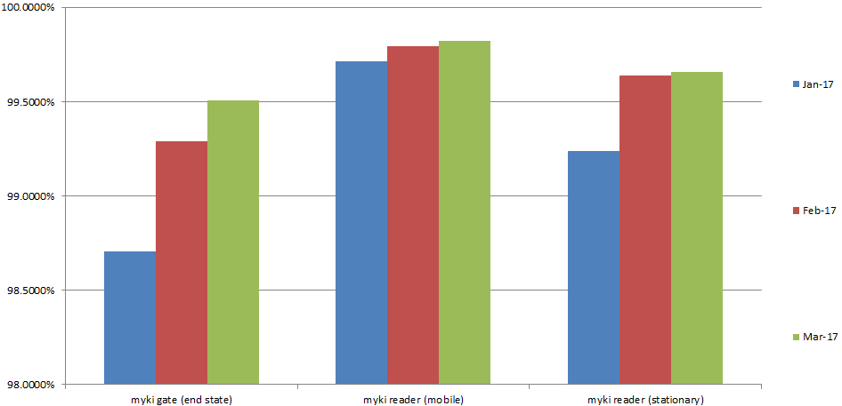
Note: KPI regime under TSSA has changed compared to AD6, as such data from 1 January 2017 is not comparable to prior data.

Monitoring of ticketing equipment

The status of ticketing equipment at railway stations is monitored via fixed communication. NTT Data therefore has accurate and up-to-date information on the availability of ticketing machines at railway stations and can promptly schedule repairs or servicing.

Mobile equipment on board trams and buses utilises wireless communications. Tram and bus operators are required to make vehicles with faulty equipment available to NTT Data for repairs and services. Measures and performance targets vary between modes.

Fare evasion
Attitudes toward Authorised Officers
Figure 10: Attitudes toward Authorised Officers (per cent)

Table 19: Detailed attitudes toward Authorised Officers
Attitudes towards authorised officers | Jan-Mar 2016 | Apr-Jun 2016 | Jul-Sep 2016 | Oct-Dec 2016 | Jan-Mar 2017
Neutral | 44% | 43% | 29% | 32% | 47%
Pleased | 18% | 18% | 23% | 22% | 17%
More secure | 18% | 23% | 30% | 29% | 22%
Annoyed | 5% | 5% | 6% | 5% | 3%
Nervous | 4% | 3% | 2% | 3% | 1%
Harassed | 4% | 2% | 3% | 2% | 2%
Have not seen them | 8% | 6% | 7% | 6% | 7%
Sample size | 400 | 400 | 400 | 400 | 400
Under half (39 per cent) of public transport users reported feeling positive towards Authorised Officers in the March 2017 quarter, down significantly from last quarter (51 per cent).

The decrease in overall positive feelings is driven by an increase in those feeling neutral (from 32 per cent last quarter to 47 per cent this quarter).
Customer service

Website
PTV’s website provides journey planning, timetable, ticketing and marketing information for metropolitan Melbourne and regional Victoria. The PTV mobile phone apps for iPhones and Android handsets feature timetable and journey planning information.
Table 20: Website performance
 | Oct 2016 | Nov 2016 | Dec 2016 | Quarter total | Quarter on quarter change* | Year on year change*
Visits | 4.3m | 4.4m | 4.7m | 13.5m | +13% | +8%
Visitors | 2.0m | 1.9m | 2.0m | 4.9m* | +12% | +11%
*The quarter total for unique visitors may be higher than the aggregate of the three months as a visitor may visit the website more than once during a month, but is only counted once in the quarter total.
The PTV website received a record 13.5 million visits from customers in the March quarter. This is up 8% year-on-year on the previous record of the same quarter last year.
Activity built across the quarter, peaking in early- to mid-March. This period is the usual annual peak for usage, driven by the start of the university year.
Journey planner
Customers planned a record 39.5 million journeys using PTV’s journey planner on our website, mobile phone apps or at the call centre during the quarter. This is a 6 per cent increase on the record total of the previous quarter, and up 50 per cent on the same period last year. Much of this growth is attributable to the increasing usage of PTV’s mobile apps.
News and service alterations
Improvements works on the Frankston line, including bus replacements over several weeks was the quarter’s most-viewed news article, with V/Line cancellations and coach replacements also driving a lot of activity.
Mobile apps
PTV mobile apps were installed by 184,000 new customers during the quarter, and updates to both our iOS and Android apps were released in February.
Figure 11: Website visits

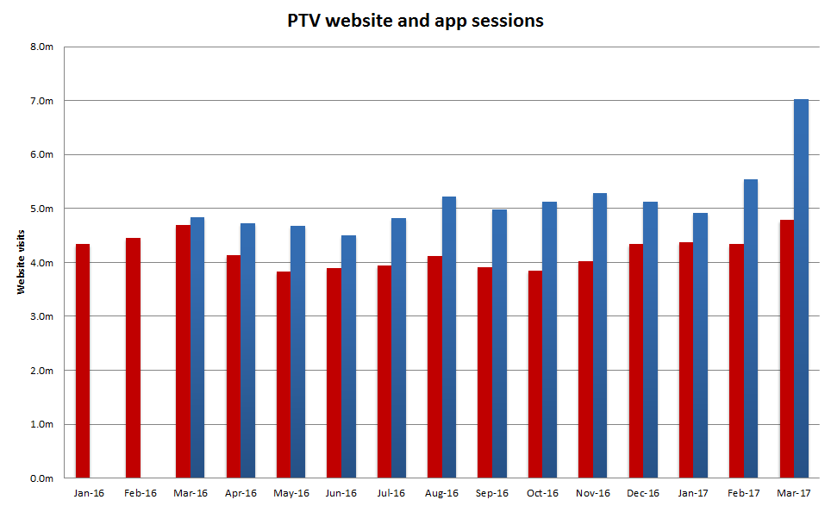

Source: Google analytics
Table 21: Website visits
Month | Jan 2016 | Feb 2016 | Mar 2016 | Apr 2016 | May 2016 | Jun 2016 | Jul 2016 | Aug 2016 | Sep 2016
Website visits | 4,334,701 | 4,446,234 | 4,686,265 | 4,131,197 | 3,824,990 | 3,887,248 | 1,785,687 | 1,906,603 | 1,825,140
App visits | N/A | N/A | 4,842,737 | 4,720,286 | 4,679,908 | 4,501,484 | 4,819,738 | 5,216,392 | 4,980,793

Month | Oct 2016 | Nov 2016 | Dec 2016 | Jan 2016 | Feb 2016 | Mar 2016
Website visits | 3,850,042 | 4,020,020 | 4,336,537 | 4,334,701 | 4,446,234 | 4,686,265
App visits | 5,124,999 | 5,289,706 | 5,129,984 | 4,921,646 | 5,543,405 | 7,018,876

Call Centre
PTV’s Call Centre provides journey and ticket information for metropolitan and regional services, as well as taking reservations and payment for V/Line tickets. It also collects feedback on behalf of all operators.
Table 22: Call Centre calls received
Measure | Oct 2016 | Nov 2016 | Dec 2016 | Quarter Total | Quarter on quarter change | Year on year change
Calls received | 110,233 | 99,327 | 115,463 | 325,023 | +3.9% | +0.2%
Call volumes increased 3.9 per cent this quarter and 0.2 per cent against the same period last year.
Figure 12: Call Volumes and Grade of Service (per cent)
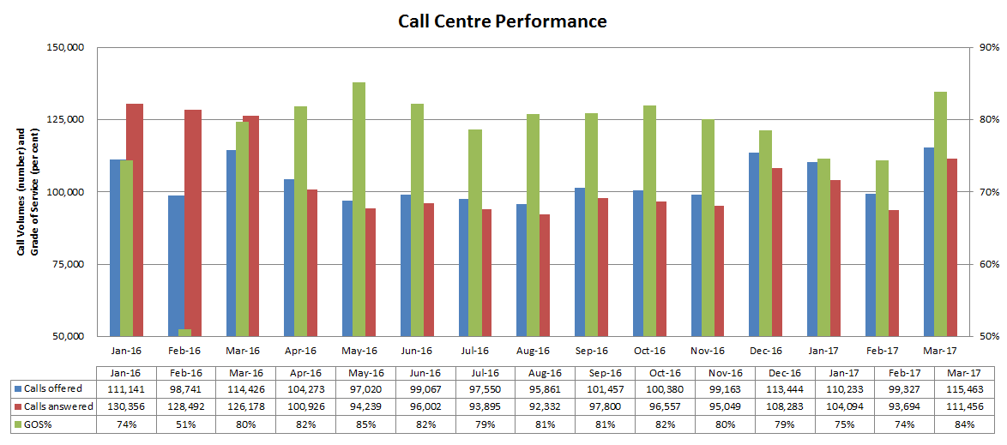
Table 23: Call Volumes and Grade of Service (per cent)
Calls | Jan 2016 | Feb 2016 | Mar 2016 | Apr 2016 | May 2016 | Jun 2016 | Jul 2016 | Aug 2016 | Sep 2016 | Oct 2016 | Nov 2016 | Dec 2016 | Jan 2017 | Feb 2017 | Mar 2017
offered | 111,141 | 98,741 | 114,426 | 104,273 | 97,020 | 99,067 | 97,550 | 95,861 | 101,457 | 100,380 | 99,164 | 113,444 | 110,233 | 99,327 | 115,463
answered | 130356 | 128492 | 126178 | 100,926 | 94,239 | 96,002 | 93,895 | 92,332 | 97,800 | 96,557 | 95,049 | 108,283 | 104,094 | 93,694 | 111,456
GOS% | 74% | 51% | 80% | 82% | 85% | 82% | 79% | 81% | 81% | 82% | 80% | 78% | 75% | 74% | 84%
The Grade of Service target of 80 per cent of calls answered within 30 seconds was not met in January (75 per cent) and February
(74 per cent), but was met in March (84 per cent).

Industry-wide feedback

About industry feedback
Feedback data from all operators who have Resolve (Metro, Yarra, V/Line and PTV), is collected in a central database to aid industry-wide reporting and analysis. Bus data is provided to PTV by BusVic on behalf of its members.

Stakeholder share
During the December quarter, stakeholders reported receiving 22,817 cases (excluding special needs booking requests); this was a 12 per cent increase on the previous quarter, and yet down by 9 per cent year-on-year.
PTV received 4,313 primary cases during the quarter; a 12 per cent increase on the previous quarter, and a decrease of 9 per cent year-on-year.
Figure 13: Resolve – Stakeholder share
Table 24: Resolve – Stakeholder share
Operator | Total number of cases | Share of all cases | Quarter-on-quarter change | Year-on-year change
Metro Trains | 5,902 | 23% | 6% | -17%
Yarra Trams | 3,236 | 12% | 10% | -11%
Bus | 7,775 | 30% | 12% | 32%
V/Line | 3,808 | 15% | 38% | -11%
Public Transport Victoria | 5,195 | 20% | 23% | 14%
Total | 25,916 | 100% | 16% | 2%
* Special needs booking requests have been removed
Types of feedback
Figure 14: Types of feedback

Table 25: Types of feedback
Feedback type | Percentage
Complaint | 81.5%
Compliment | 2.7%
Enquiry | 5.3%
Suggestion | 2.3%
Others | 8.1%

Industry feedback
Figure 15: Top five feedback issues across the industry

Note: Top issues for cases entered into the Resolve database (excluding performance-based compensation claims and compliments).
Table 26: Top five feedback issues across the industry
Issue | Percentage
Service delivery | 33.4%
Provision of information | 16.8%
Infrastructure | 16.4%
Staff | 13.2%
Ticketing and policy | 7.1%
Note: Top issues for cases entered into the Resolve database (excluding performance-based compensation claims and compliments).
Table 27: Breakdown of top industry issue*
Issue | Percentage
Delayed | 25.8%
Service Change Needed | 16.9%
Service Disruption | 11.1%
Overcrowding | 10.8%
System Improvement | 9.3%
*Top industry feedback issue: Service delivery – 33.4 per cent of cases
Note: Bus industry feedback categorisation does not currently allow for analysis beyond the top PTV issues feedback.

PTV feedback
Excluding compliments, Provision of information was the top feedback issue of the quarter, accounting for 33 per cent of PTV cases.
Mobile Products accounted for 47 of the feedback received under Provision of information.
40 per cent of the feedback came from the iPhone - PTV App 3.1.0. Issues consist of:
> Train Real time
> Accuracy
> Future Enhancement
Service delivery accounted for 28 per cent of all PTV Cases. Requests include:
> System improvement
> Service change needed
> Modal coordination
Some 0.90 per cent of cases received during the quarter were compliments. The top compliments were Staff and Service delivery (accounting for 51 per cent of compliments).
> 61 per cent of the compliments from Staff related to Call Centre
> 71 per cent of the compliments from Service delivery related to Service Change Needed
Figure 16: PTV top five feedback issues

Note: Bus industry feedback categorisation does not currently allow for analysis beyond the top PTV issues feedback.
Table 28: PTV top five feedback issues
Issue | Percentage
Provision of information | 32.9%
Service delivery | 28.1%
Ticketing and policy | 18.0%
Infrastructure | 15.5%
Staff | 3.1%
Note: Top issues for cases entered into the Resolve database (excluding performance-based compensation claims and compliments).
Table 29: Breakdown of top PTV issue*
Issue | Percentage
Mobile Products | 46.6%
Website | 20.1%
Timetable | 15.7%
Journey Planner | 5.0%
Information Request | 4.0%
*Top PTV issue: Provision of Information: 32.9 per cent of cases
Note: Bus industry feedback categorisation does not currently allow for analysis beyond the top PTV issues feedback.

